Proxy Server

🧭 What is a Proxy Server?
# Source: AI Source: Provided by: [Data Path: Persons Table -> ID Column: 1, Name_En Column: Motasem Essam] -> From: [ChatGPT] on [1/16/2026]
A proxy server (or proxy) is an intermediary between your device and the internet. When you use a proxy, your requests (like visiting a website) go through the proxy server first, and then it sends the response back to you.
📌 In simple terms: a proxy is a middleman for your internet traffic.

🧠 How It Works
# Source: AI Source: Provided by: [Data Path: Persons Table -> ID Column: 1, Name_En Column: Motasem Essam] -> From: [ChatGPT] on [1/16/2026]
Without a proxy:
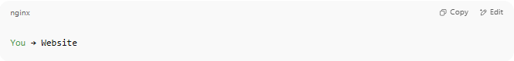
You → Website

With a proxy:

You → Proxy Server → Website → Proxy Server → You

The website sees the proxy as the visitor — not you.

🧠 Simple Example
# Source: AI Source: Provided by: [Data Path: Persons Table -> ID Column: 1, Name_En Column: Motasem Essam] -> From: [ChatGPT] on [1/16/2026]
You open a website using a proxy:
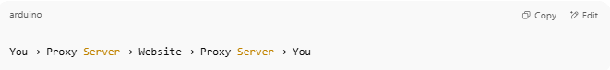
You → Proxy Server → Website → Proxy Server → You

The website doesn’t see your IP address, only the proxy’s.

🎯 Why Use a Proxy Server?
# Source: AI Source: Provided by: [Data Path: Persons Table -> ID Column: 1, Name_En Column: Motasem Essam] -> From: [ChatGPT] on [1/16/2026]
Purpose | Benefit
🌐 Privacy | Hides your IP from the destination website
🛑 Filtering | Blocks certain websites (e.g., in schools)
🔓 Bypassing blocks | Access restricted or geo-blocked content
🚀 Caching | Speeds up repeated requests
🧩 Control | Allows admins to monitor or limit internet use

🧩 Common Types of Proxies
# Source: AI Source: Provided by: [Data Path: Persons Table -> ID Column: 1, Name_En Column: Motasem Essam] -> From: [ChatGPT] on [1/16/2026]
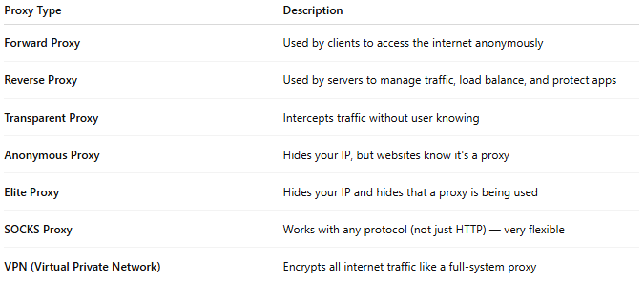
Proxy Type | Description
Forward Proxy | Used by clients to access the internet anonymously
Reverse Proxy | Used by servers to manage traffic, load balance, and protect apps
Transparent Proxy | Intercepts traffic without user knowing
Anonymous Proxy | Hides your IP, but websites know it's a proxy
Elite Proxy | Hides your IP and hides that a proxy is being used
SOCKS Proxy | Works with any protocol (not just HTTP) — very flexible
VPN (Virtual Private Network) | Encrypts all internet traffic like a full-system proxy

🔐 Proxy vs VPN
# Source: AI Source: Provided by: [Data Path: Persons Table -> ID Column: 1, Name_En Column: Motasem Essam] -> From: [ChatGPT] on [1/16/2026]
Feature | Proxy | VPN
Encrypts data | ❌ No (unless using HTTPS) | ✅ Yes (full encryption)
Hides IP | ✅ Yes | ✅ Yes
Scope | Per app or browser | Entire device/system-wide
Speed | Usually faster (lighter) | Slightly slower (heavier)

✅ Summary
# Source: AI Source: Provided by: [Data Path: Persons Table -> ID Column: 1, Name_En Column: Motasem Essam] -> From: [ChatGPT] on [1/16/2026]
Feature | Description
Role | Middleman between you and the internet
Uses | Privacy, filtering, speed, control
Examples | Squid, Nginx (reverse proxy), Proxifier

